Operating System as a Resource Manager
A computer has many resources (Hardware and Software), which may be required to complete a task. The commonly required resources are Input/Output devices, Memory file storage space, CPU (Central Processing Unit) time and so on.
The operating system acts as the manager of these resources and allocates them to specific programs and users as necessary for their tasks. Therefore, we can say an operating system is a resource allocator. This is the main features of an operating system.
When a number of computers connected through a network more than one computer trying for a computer print or a common resource, then the operating system follows same order and manage the resources in an efficient manner.
Generally, resources sharing in two ways "in time" and "in space". When a resource is a time-sharing resource, first one of the tasks get the resource for some time, then another and so on.
For example, a CPU in the time-sharing system. In the time-sharing system, OS fixes the time slot for the CPU. First one of the processes gets the CPU, when the time slot expires, the CPU switch to the next process in the ready queue. In this example, the CPU is a time resource. CPU Scheduling in Operating System
The other kind of sharing is the "space sharing". In this method, the users share the space of resource. For example, the main memory consisting of several processes at a time, so the process of sharing the resources.
The main difference between "in time" sharing resources and "in space" sharing resources is "in time" resources are not divided into units, whereas "in space" sharing resources are divided into units.

CPU Scheduling Algorithms Problems With Solutions

Today we will practice problems on different types of CPU Scheduling Algorithms. We will see here that how CPU scheduler uses scheduling algorithms during execution of process. Let's see.

- FCFS Example
- Shortest Job First Scheduling
- Round Robin Scheduling Example
- Shortest Remaining Time First(SRTF)
- Priority Scheduling Example

FCFS Example
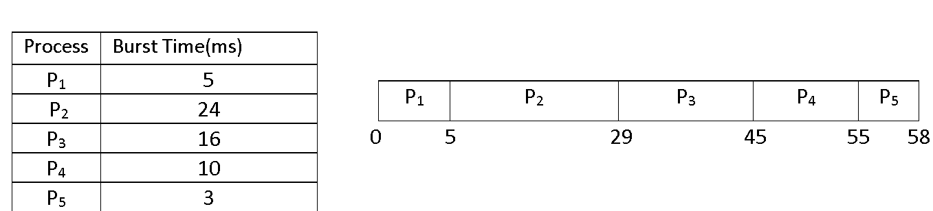
FCFS Scheduling

FCFS Example
Consider the above set of processes that arrive at time zero. The length of the CPU burst time given in millisecond.
Now we calculate the average waiting time, average turnaround time and throughput.

Average Waiting Time and Turnaround Time

Average Waiting Time
First of all, we have to calculate the waiting time of each process.
Waiting Time = Starting Time - Arrival Time
Waiting time of
P1 = 0
P2 = 5 - 0 = 5 ms
P3 = 29 - 0 = 29 ms
P4 = 45 - 0 = 45 ms
P5 = 55 - 0 = 55 ms
Average Waiting Time = Waiting Time of all Processes / Total Number of Process
Therefore, average waiting time = (0 + 5 + 29 + 45 + 55) / 5 = 25 ms

Average Turnaround Time
Turnaround Time = Waiting time in the ready queue + executing time + waiting time in waiting-queue for I/O
Turnaround time of
P1 = 0 + 5 + 0 = 5ms
P2 = 5 + 24 + 0 = 29ms
P3 = 29 + 16 + 0 = 45ms
P4 = 45 + 10 + 0 = 55ms
P5 = 55 + 3 + 0 = 58ms
Total Turnaround Time = (5 + 29 + 45 + 55 + 58) ms = 192ms
Average Turnaround Time = (Total Turnaround Time / Total Number of Process) = (192 / 5) ms = 38.4ms

Throughput
Here, we have a total of five processes. Process P1, P2, P3, P4, and P5 takes 5ms, 24ms, 16ms, 10ms, and 3ms to execute respectively.
Throughput = (5 + 24 +16 + 10 +3) / 5 = 11.6ms
It means one process executes in every 11.6 ms.

SJF (Shortest Job First) Scheduling
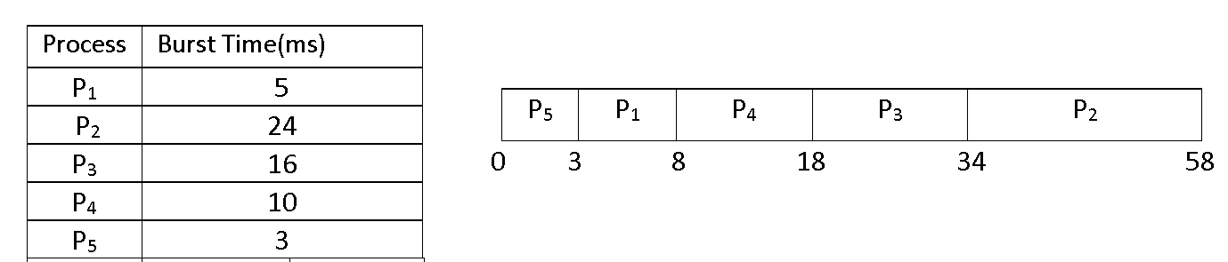
SJF Scheduling

Average Waiting Time and Turnaround Time

Average Waiting Time
We will apply the same formula to find average waiting time in this problem. Here arrival time is common to all processes(i.e., zero).
Waiting Time for
P1 = 3 - 0 = 3ms
P2 = 34 - 0 = 34ms
P3 = 18 - 0 = 18ms
P4 = 8 - 0 = 8ms
P5 = 0 – 0 = 0ms
Now, Average Waiting Time = (3 + 34 + 18 + 8 + 0) / 5 = 12.6ms

Average Turnaround Time
According to the SJF Gantt chart and the turnaround time formulae,
Turnaround Time of
P1 = 3 + 5 = 8ms
P2 = 34 + 24 = 58ms
P3 = 18 + 16 = 34ms
P4 = 8 + 10 = 18ms
P5 = 0 + 3 = 3ms
Therefore, Average Turnaround Time = (8 + 58 + 34 + 18 + 3) / 5 = 24.2ms

Throughput
Here, we have a total of five processes. Process P1, P2, P3, P4, and P5 takes 5ms, 24ms, 16ms, 10ms, and 3ms to execute respectively.
Therefore, Throughput will be same as above problem i.e., 11.6ms for each process.

Round Robin Scheduling Example
Here is the Round Robin scheduling example with gantt chart. Time Quantum is 5ms.
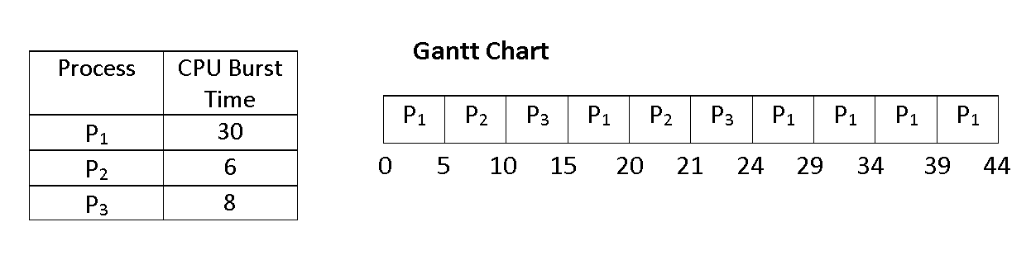
Round Robin Scheduling

Average Waiting Time and Turnaround Time

Average Waiting Time
For finding Average Waiting Time, we have to find out the waiting time of each process.
Waiting Time of
P1 = 0 + (15 - 5) + (24 - 20) = 14ms
P2 = 5 + (20 - 10) = 15ms
P3 = 10 + (21 - 15) = 16ms
Therefore, Average Waiting Time = (14 + 15 + 16) / 3 = 15ms

Average Turnaround Time
Same concept for finding the Turnaround Time.
Turnaround Time of
P1 = 14 + 30 = 44ms
P2 = 15 + 6 = 21ms
P3 = 16 + 8 = 24ms
Therefore, Average Turnaround Time = (44 + 21 + 24) / 3 = 29.66ms

Throughput
Throughput = (30 + 6 + 8) / 3 = 14.66ms
In 14.66ms, one process executes.

Shortest Remaining Time First(SRTF)
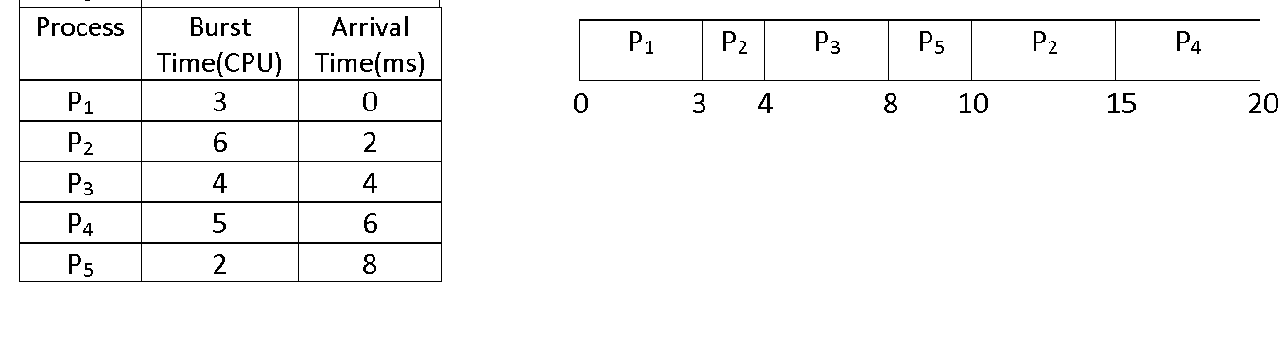
SRTF Scheduling

Average Waiting Time and Turnaround Time

Average Waiting Time
First of all, we have to find the waiting time for each process.
Waiting Time of process
P1 = 0ms
P2 = (3 - 2) + (10 - 4) = 7ms
P3 = (4 - 4) = 0ms
P4 = (15 - 6) = 9ms
P5 = (8 - 8) = 0ms
Therefore, Average Waiting Time = (0 + 7 + 0 + 9 + 0) / 5 = 3.2ms

Average Turnaround Time
First of all, we have to find the turnaround time of each process.
Turnaround Time of process
P1 = (0 + 3) = 3ms
P2 = (7 + 6) = 13ms
P3 = (0 + 4) = 4ms
P4 = (9 + 5) = 14ms
P5 = (0 + 2) = 2ms
Therefore, Average Turnaround Time = (3 + 13 + 4 + 14 + 2) / 5 = 7.2ms

Throughput
Troughput = (3 + 6 + 4 + 5 + 2) / 5 = 4ms
Therefore, each process takes 4ms to execute.

Priority Scheduling Example
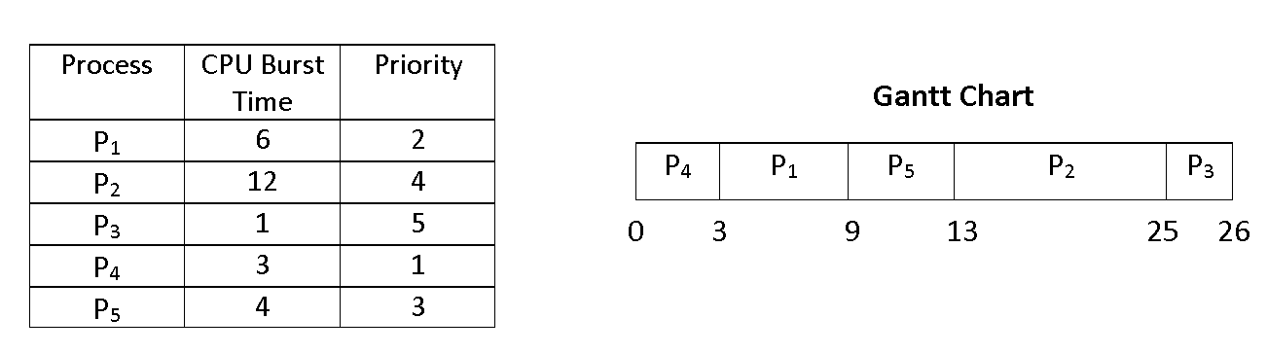
Priority Scheduling Example with Gantt Chart

Average Waiting Time and Turnaround Time

Average Waiting Time
First of all, we have to find out the waiting time of each process.
Waiting Time of process
P1 = 3ms
P2 = 13ms
P3 = 25ms
P4 = 0ms
P5 = 9ms
Therefore, Average Waiting Time = (3 + 13 + 25 + 0 + 9) / 5 = 10ms

Average Turnaround Time
First finding Turnaround Time of each process.
Turnaround Time of process
P1 = (3 + 6) = 9ms
P2 = (13 + 12) = 25ms
P3 = (25 + 1) = 26ms
P4 = (0 + 3) = 3ms
P5 = (9 + 4) = 13ms
Therefore, Average Turnaround Time = (9 + 25 + 26 + 3 + 13) / 5 = 15.2ms

Throughput
Throughput = (6 + 12 + 1 + 3 + 4) / 5 = 5.2ms
Therefore, each process takes 5.2ms to execute.

CPU Scheduling
CPU Scheduling in operating system is a fundamental function, almost all computer resources scheduled before use. The CPU is also one of the primary resources. So, CPU scheduling before use. The Scheduling Algorithms determine how the CPU will be allocated to the process.
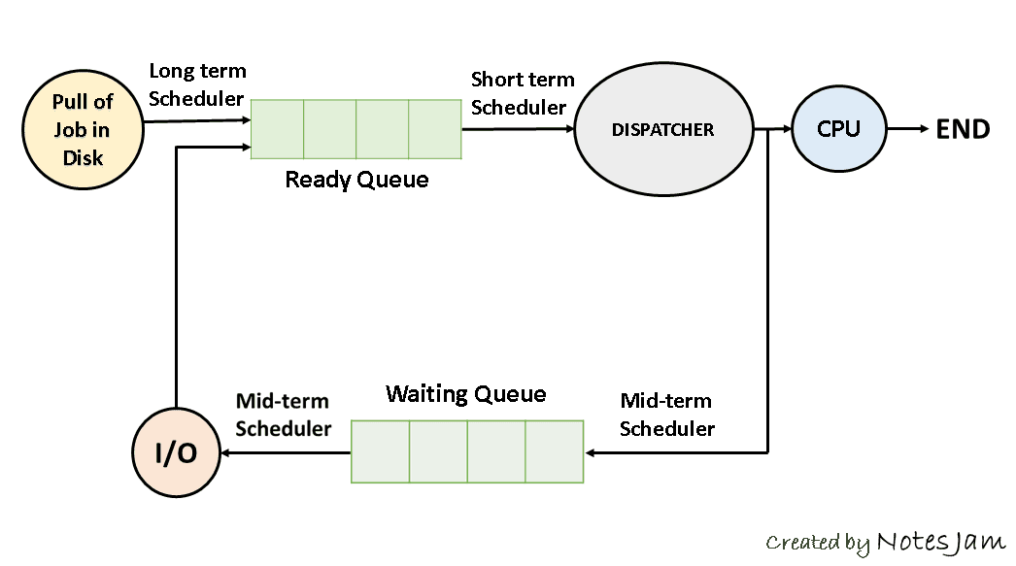
CPU Scheduling
CPU Scheduling in Operating System
CPU scheduling in the operating system is the basis of the multi-programmed operating system. The idea of multiprogramming is relatively simple if a process(job) is waiting for an I/O request, then the CPU switches from the process to another through a dispatcher, so the CPU is always busy in multiprogramming.
But in a simple computer system, the CPU sits idle until the I/O request granted. By switching the CPU among process, the OS can make the computer more productive.

Types of CPU Scheduling
CPU scheduling has two types-Non-Preemptive and Preemptive

Non-Preemptive Scheduling
In the non-preemptive scheduling, once the CPU assigned to a process, the processor does not release until the completion of that process. The CPU will be assigned to another job only after the previous has finished.

Preemptive Scheduling
In the preemptive scheduling algorithm, the CPU can release the process even in the middle of the execution. For example, the CPU executing the process P1, in the middle of the execution the CPU receives a request signal from process P2. Then the OS compares the priorities of P1 and P2.

CPU Scheduler in OS
CPU schedulers in operating system are:

Long-term Scheduler
The function of a long-term scheduler is to select the jobs from the pool of jobs and load these jobs into main memory (Ready Queue) of that computer, so the long-term scheduler is also called job-scheduler.

Short-term Scheduler
The function of a short-term scheduler is to select a job from the ready queue and gives the control of the CPU to that process with the help of "Dispatcher". That's why the short-term scheduler is also said to be the CPU scheduler.
The method of selecting a process from the ready queue by the short-term scheduler is depending on the Scheduling algorithms.

Medium-term Scheduler
If a process requests an I/O in the middle of execution, then the process removed from the main memory is loaded into the waiting queue. When the I/O operation is completed, then the job moved from waiting queue to ready queue. These two operations are performed by the medium-term scheduler.

Dispatcher in OS
A dispatcher is a module, it connects the CPU to the process selected by the short-term scheduler. The main function of the dispatcher is switching, it means switching the CPU from one process to another process.
Another function of the dispatcher is jumping to the proper location in the user program and ready `to start execution. The time taken by the dispatcher to stop one process and start another running is called the Dispatch Latency in OS.
The degree of multiprogramming is dependent on the dispatch latency. If the dispatch latency is increasing, then the degree of multiprogramming decreases.

CPU Scheduling Criteria in OS

Throughput in OS
It means how many jobs are completed by the CPU.

Turnaround Time in OS
The time interval between the submission of the process and the time of the completion is the turnaround time.
Important
Turnaround time = Waiting time in the ready queue + executing time + waiting time in waiting queue for I/O.

Waiting Time in OS
Waiting time is the sum of the periods spent waiting by a process in the ready queue.

Response Time in OS
Response time is the time duration between the submission and the first response.

CPU Utilization in OS
This is the percentage of time that the processor is busy, CPU utilization may range from 0-100%.
I hope you have cleared about CPU Scheduling in OS, you also learned types of scheduling, Scheduling criteria, dispatcher and three kinds of schedulers i.e., long term, short term, and medium-term scheduler.

